ONCOSPECTRA
Revolutionising Oral Cancer Screening
Discover a Breakthrough in Oral Cancer Detection with OncoSpectra, a cutting-edge optical spectroscopy-based healthcare instrument.

Onco-spectra swiftly identifies pre-cancerous or cancerous lesions. Enhances early detection, improving patient outcomes. Compact & Portable, Oncospectra pioneers optical spectroscopy in oral cancer screening.

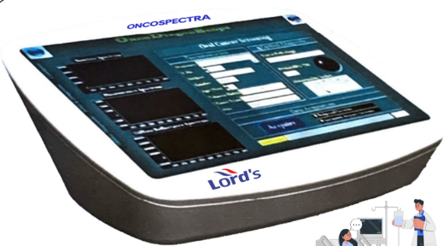

Drawbacks of Current Methods
Biopsy, the gold standard, is invasive and prone to errors.

Optical Spectroscopy Screening
- Non-invasively determines tissue type using fluorescence.
- Comfortable for patients, eliminates the need for invasive biopsies.

Real-Time Lesion Detection
- OncoSpectra swiftly identifies pre-cancerous or cancerous lesions.
- Enhances early detection, improving patient outcomes.

Validation & Accuracy
- Rigorous validation on oral neoplasia patients demonstrates over 90% accuracy.
- Proven effectiveness in various hospitals and cancer screening camps

Features:
- Optical Spectroscopy Principle
Utilises fluorescence and diffuse reflectance for accurate tissue analysis.
- Compact & Portable
Sleek design for convenient use in various healthcare settings.
- Touch-screen GUI Software
User-friendly interface for easy operation, and data documentation.
- Instant Diagnostic Feedback
Displays coloured flashes providing insights into tissue health.
- Tablet Battery Powered
Operates on a peripheral tablet battery, eliminating the need for an extra power source.

Application
- Standalone Screening Tool
Ideal for screening populations at risk of oral cancer, equipped with a user-friendly GUI.
- Real-time Lesion Detection
Non-invasive detection of pre-cancerous or cancerous lesions in less than 15 minutes per subject.
Dramatically reduces investigation time compared to conventional biopsy procedures (48 hrs).

